Mathematics Specialist Unit 3

Test 2: Polynomials and Functions

Solutions

Student Name: _________________________

Time allowed for this task: 55 minutes, in class, under test conditions

Section One – calculator-free section 22 minutes (21 marks)

Section Two – calculator-assumed section 33 minutes (32 marks)

Materials required: Calculator with CAS capability (to be provided by the student)

Standard items: Pens (blue/black preferred), pencils (including coloured), sharpener, correction fluid/tape, eraser, ruler, highlighters.

Special items: Drawing instruments, templates, and up to three calculators approved for use in WACE examinations.
One page of A4 notes, written on both sides.
Mathematics Specialist formulae sheet.

Marks available: 53 marks

Task weighting: 7%

Section One – calculator-free section

Question 1. (4 marks)

If $f\left(x\right)=x^{2}+1$ and $g\left(x\right)=$ $\frac{2}{x}$ find the natural domain and corresponding range for

- fog(x) = $\frac{4}{x^{2}}$ + 1 (2)

$x≠0 \underset{→}{g} y≠0 \underset{→}{f} y>1$
$x≠0$

$dom(fog)=\left\{x∈R,x≠0\right\}$

$ran(fog)=\left\{y∈R,y>1\right\}$

- gof(x) = $\frac{2}{x^{2}+1}$ (2)

$x∈R \underset{→}{f} y≥1 \underset{→}{g} 0< y≤2$
$x≥1$

$dom(gof)=\left\{x∈R\right\}$
$ran(gof)=\left\{y∈R,0<y≤2\right\}$

Question 2. (4 marks)

Find an expression for the inverse function of $h$ where $h\left(x\right)=1+$ $\frac{1}{3+x}$ and state the domain and range of $h^{-1}$ .
$y=1+$ $\frac{1}{3+x}$ , $x≠-3 , y≠1$

invert $⇒$ $x=1+$ $\frac{1}{3+y}$ $⇒ x-1=$ $\frac{1}{3+y}$ $⇒$ 3+y = $\frac{1}{x-1}$ $⇒ y=$ $\frac{1}{x-1}$ $–3$

${∴ h}^{-1}(x)=$ $\frac{1}{x-1}$ $–3$

$domh^{-1}=\left\{x∈R,x≠1\right\}$
$ranh^{-1}=\left\{y∈R,y≠-3\right\}$

Question 3. (2 marks)

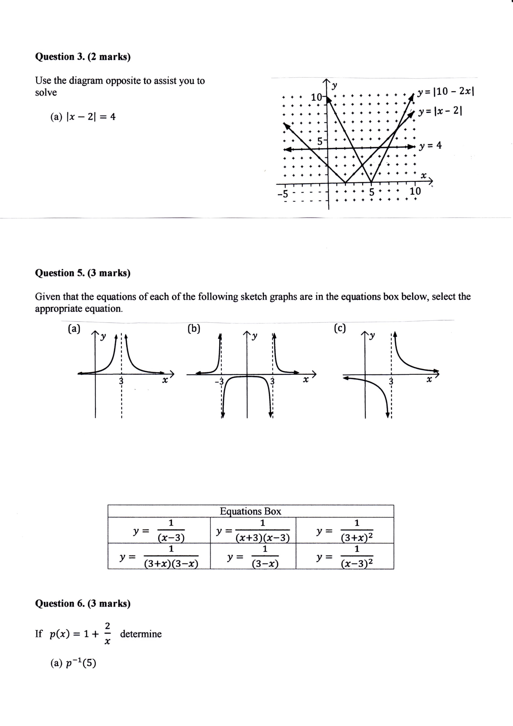
Use the diagram opposite to assist you to
solve

- $\left|x-2\right|=4$

$x=-2 , 6$

- $\left|10-2x\right|=\left|x-2\right|$

$x=4 , 8$

Question 4. (4 marks)

Consider the nature of the graph of $y=$ $\frac{x^{2}-3x-4}{x^{3}-2x^{2}-3x}$ . Describe the effect on the y values of the
graph as
$y=$ $\frac{(x-4)(x+1)}{x(x-3)(x+1)}$ = $\frac{(x-4)}{x(x-3)}$ $, x≠-1$

- x tends to $+∞$ $y⟶0$

- x tends to $3^{+}$ $y⟶-∞$ $\frac{(x-4)}{x(x-3)}$ $=$ $\frac{-ve}{+ve.+ve}$

- x tends to $-1^{-}$ $y⟶$ $-\frac{5}{4}$ $\frac{(x-4)}{x(x-3)}$ = $\frac{(-1-4)}{\left(-1\right)(-1-3)}$ open point ($-1, -\frac{5}{4}$)

- x tends to $4^{-}$ $y⟶0$ $\frac{(x-4)}{x(x-3)}$ = 0 at $x=4$

Question 5. (3 marks)

The graph of $y=-2\left|x-4\right|+6$ is shown below. Find $a, b$and $c$ such that the solution to the equation

$-2\left|x-4\right|+6=a\left|x+b\right|+c$ is $4≤x≤6$.

y
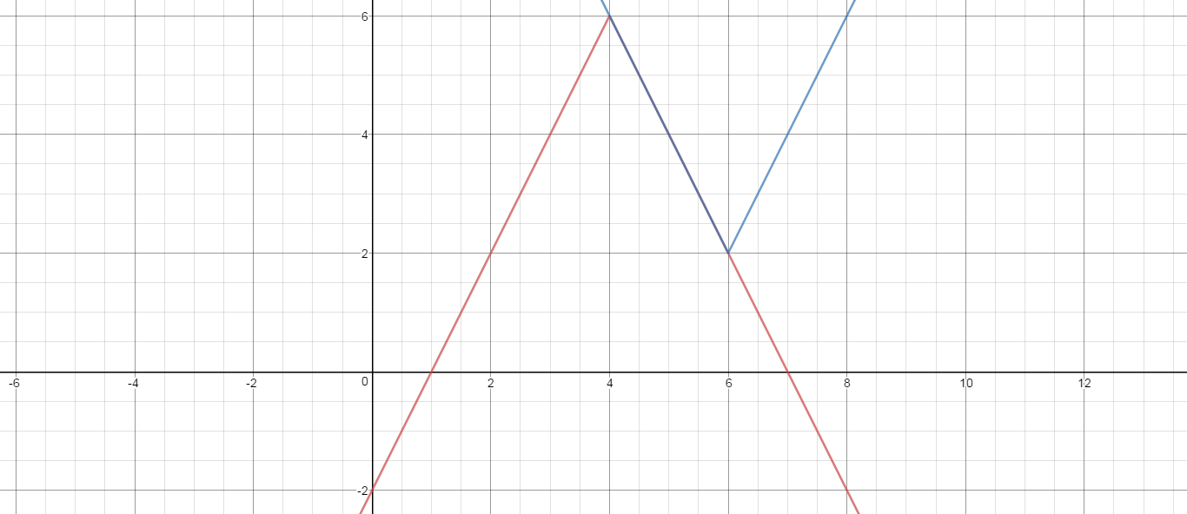

x

Gradient 2$⇒ a=2$ and vertex at $\left(6,2\right)⇒b=-6, c=2$

Question 6. (4 marks)

If $p\left(x\right)=1+$ $\frac{2}{x}$ determine

- $p^{-1}(5)$ Put $5=$ $1+$ $\frac{2}{x}$ $⟹$ $4=$ $\frac{2}{x}$ $⟹$ $x=\frac{1}{2}$ (2)

$∴(\frac{1}{2}$ , 5)$∈ p ⟹$ $\left(5 , \frac{1}{2}\right) ∈ p^{-1}$

$p^{-1}\left(5\right)= \frac{1}{2}$

- The value(s) of x such that $p^{-1}(x)=p(x)$. (2)

${ p}^{-1}\left(x\right)=p\left(x\right)=x$
$∴$ $1+$ $\frac{2}{x}$ $=x$
$x+2=x^{2}$
$0=x^{2}-x-2$
$0=(x-2)(x+1)$
$x=2 , -1$

End of Section One
Section Two – calculator-assumed section

Question 7. (4 marks)

The graph of $y=p(x)$ is shown twice below. In diagram (a) show the graph of $y=p(\left|x\right|)$ while in diagram (b) show the graph of$y=\left|p(x)\right|$.

(a) y (b) y
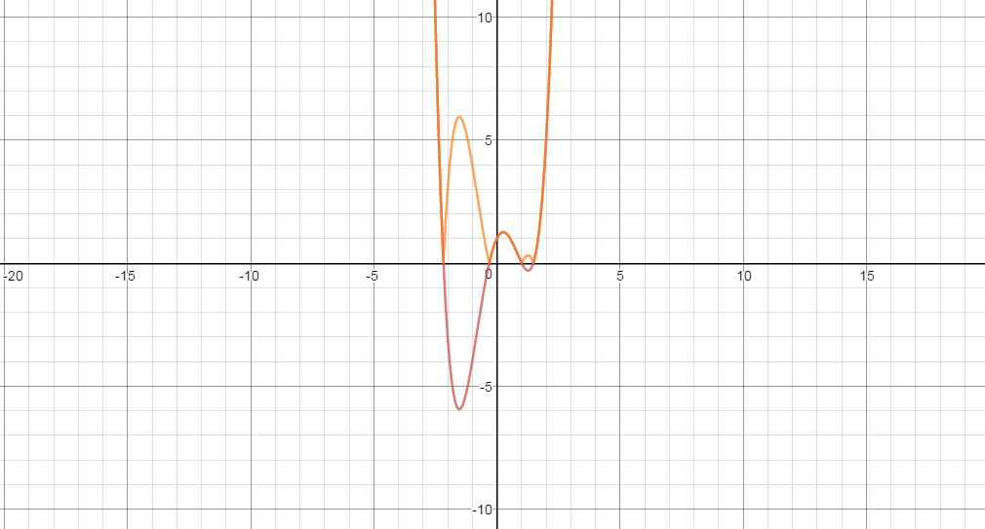
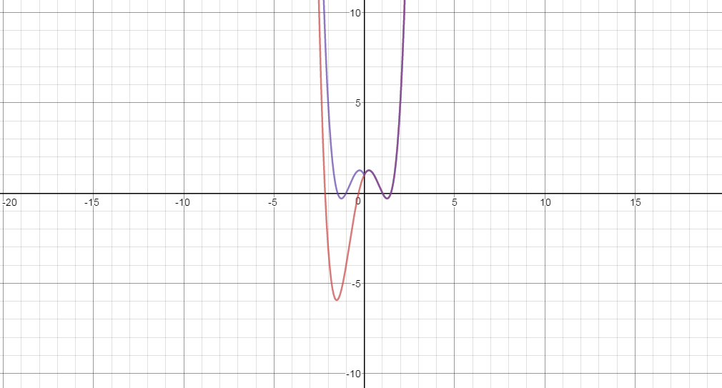

x x

Question 8. (3 marks)

Find an expression for the inverse function of $f(x)$ where $f\left(x\right)=4+$ $\frac{2}{2x-1}$ and state its
domain and range.

$y=4+$ $\frac{2}{2x-1}$ $⇒$ $x=4+$ $\frac{2}{2y-1}$ $⇒$ $y=$ $\frac{x-2}{2(x-4)}$

$∴$ $f^{-1}(x)=$ $\frac{x-2}{2(x-4)}$ Use solve ($x=4+$ $\frac{2}{2y-1} ,y)$ on classpad

$domf=\left\{xϵR,x≠\frac{1}{2}\right\}$ $∴ranf^{-1}=\left\{yϵR,y≠\frac{1}{2}\right\}$

$ranf=\left\{yϵR,y≠4\right\}$ $∴domf^{-1}=$ $\left\{xϵR,x≠4\right\}$

Question 9. (4 marks)

Given that $p\left(x\right)=x^{2}-4$ and $q\left(x\right)=$ $\frac{1}{x}$ state the natural domain and the corresponding
range of each of the following functions:

- $poq(x)$ = $\frac{1}{x^{2}}$ $– 4$ (2)
$x≠0 \underset{→}{q} y,x≠0 \underset{→}{p} y>-4$

$dom\left(poq\right)=\left\{xϵR,x≠0\right\}$

$ran\left(poq\right)=\left\{yϵR,y>-4\right\}$

- $qop(x)$ = $\frac{1}{x^{2}-4}$ (2)

$xϵR \underset{→}{p} y,x≥-4 \underset{→}{q} y≤-\frac{1}{4} or y>0$
$x≠±2 x≠0$

$dom\left(qop\right)=\{xϵR,x≠±2\}$

$ran\left(qop\right)=\left\{yϵR,y≤-\frac{1}{4} or y>0\right\}$

Question 10. (6 marks)

Determine all of the asymptotes for each of the following functions:

- T(x) = $\frac{x^{2}+3x}{x-1}$ $⟹$ vertical asymptote at $x=1$ (2)

$=x+4+$ $\frac{4}{x-1}$ $⟹$ oblique asymptote at $y=$ $x+4$

- U(x) = $\frac{x^{2}-9}{x(x+3)}$ $=$ $\frac{(x-3)(x+3)}{x(x+3)}$ $=$ $\frac{x-3}{x}$ , x$≠-3$ (2)

vertical asymptote at $x=0$ open point at ($-3, 2)$
horizontal asymptote at $y=1$

- V(x) = $\frac{x^{2}+1}{(2x-3)(x+2)}$ (2)

vertical asymptotes at $x=-2, 1\frac{1}{2}$
horizontal asymptote at $y=\frac{1}{2}$

Question 11. (4 marks)

Consider the graph of $y=$ $\frac{x^{2}+x-2}{x^{3}-2x^{2}-x+2}$ $=$ $\frac{(x-1)(x+2)}{(x-1)(x-2)(x+1)}$ $=$ $\frac{x+2}{(x-2)(x+1)}$ $, x≠1$

- Locate any asymptotes. (2)
vertical asymptotes at $x=-1, 2$
horizontal asymptote at $y=0$

- Describe any other discontinuities. (2)
$\frac{1+2}{(-1)(2)}= \frac{3}{-2}=-1\frac{1}{2}$
An open point at $(1, -1\frac{1}{2} )$

Question 12. (5 marks)
The graph of $y=f(x)$ is shown below. It has asymptotes at $=2, x=6, y=-\frac{1}{2}$ . On the same set of axes draw the graph of $y=$ $\frac{1}{f(x)}$ , clearly showing any roots and asymptotes.
$y$
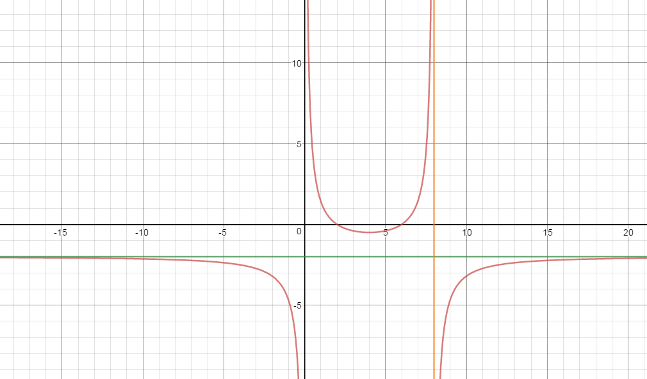

$x$

Roots at $x=2,6$
Asymptotes at $x=0 , x=8$ and $y=-2$
Turning point at $(4,-\frac{1}{2})$
Graph $y= \frac{1}{f(x)}$ intersects $y=f(x)$ at points with y-ordinate 1
Symmetry

Question 13. (6 marks)

The graph of $g\left(x\right)=$ $\frac{(x-4)(x-1)}{x-2}$ , $x<2$ is shown below:

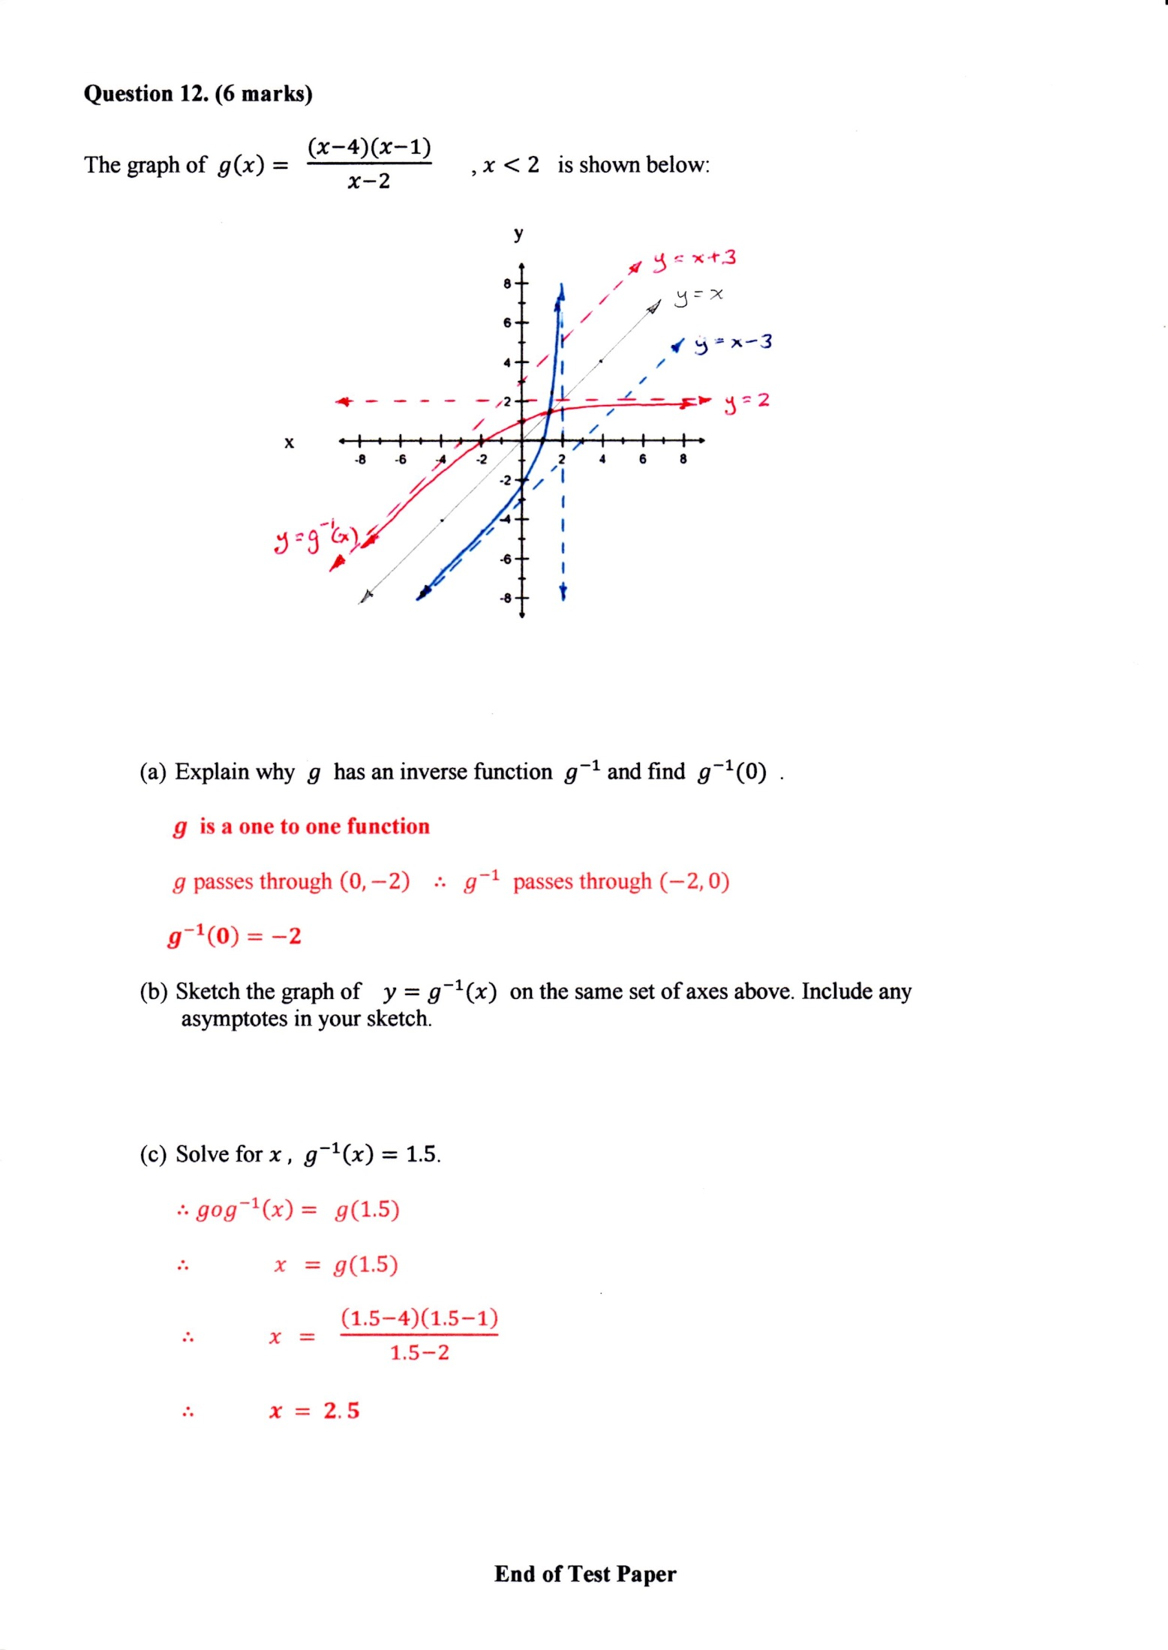

- Explain why $g$ has an inverse function $g^{-1}$ and find $g^{-1}(0)$ . (2)

$g$ is a one to one function

$g$ passes through $\left(1, 0\right) ∴ g^{-1}$ passes through $(0, 1)$

${ g}^{-1}\left(0\right)=1$

- Sketch the graph of $y=g^{-1}(x)$ on the same set of axes above. Include any
asymptotes in your sketch. (2)
The graphs, including asymptotes, of $g$ and $g^{-1}$ have symmetry about the line $y=x.$

- Solve for $x ,$ $g^{-1}\left(x\right)=1.5$. (2)

$∴gog^{-1}\left(x\right)= g(1.5)$

$∴ x = g(1.5)$

$∴ x =$ $\frac{\left(1.5-4\right)\left(1.5-1\right)}{1.5-2}$

$∴ x = 2.5$

End of Test Paper

